**INTRODUCTION**

A database is an organized collection of data. The data are typically organized to model relevant aspects of reality in a way that supports processes requiring this information. For example, modeling the availability of rooms in hotels in a way that supports finding a hotel with vacancies.

Database Management Systems (DBMS) are specially designed software applications that interact with the user, other applications, and the database itself to capture and analyze data. A general-purpose DBMS is a software system designed to allow the definition, creation, querying, update, and administration of databases. Well-known database management Software includes MySQL, MariaDB, PostgreSQL, SQLite, Microsoft SQL Server, Oracle, SAP HANA, dBASE, FoxPro, IBM DB2, LibreOffice Base and FileMaker Pro. A database is not generally portable across different database management system, but different database management can interoperate by using standards such as SQL and ODBC or JDBC to allow a single application to work with more than one database. (Bachman, 1973).

There is a need to improve the mode of doing things in the government of a nation through the organization of a standard error free and fully monitored database so that the keeping of data in every sector and arms of the government will be easier. The mode of keeping files and folders in shelves is now getting uglier and outdated and should be replaced by the modern system which will involve only few computers and its operators and can handle almost everything in the state, with less effort and complete accuracy. (Chapple, 2005).

The study of computer use by older people is currently booming, as this group has significantly increased its use of information and communication technologies (ICT) in daily life, on both personal and professional levels (Tatnall, 2014). In this respect, the advantages of using new technologies to develop social relationships, leisure and entertainment opportunities, and life-long learning habits and access services and care could be considered factors for successful autonomy and aging in the life of older people.

“As the availability of electronic resources for older adults increases, the quality of the aging experience will be enhanced” (McConatha, 2002) and in order to achieve involvement and counteract resistance to using these technologies, we need to bridge the “digital gap” experienced by older users by providing interfaces and tools adapted to suit their physical and cognitive characteristics (Hawthorn, 2000).

At present in Osun State, the state government operated a separate database system which does not comprise both government and nongovernmental workers. The database system is operated by different ministry in the state. For example the database of retirees is controlled by the pension scheme of the state which has nothing to do with nongovernmental senior citizen. This has been a major drawback for the state in controlling and monitoring the affairs of overall senior citizen in the state as a result of lack of centralized database system for senior citizen.

Hence, this paper work was carried out to develop an ICT assisted database for senior citizens of Osun State for efficient management and use of information about senior citizens of Osun State.

**LITERATURE REVIEW**

Technology has been increasing at an exponential rate and has had a profound influence on the society. This change is so rapid that it is difficult for many members of the society to keep up with its pace. There is a gap and it is widening between those who can use the technology and those who cannot. One of the citizens who have difficulty in adapting technology is senior citizens. Seniors citizens need help to keep pace with the change of rapid development in technology. Today, technology is an essential part of life for them to maintain good quality life.

Information and communications technology (ICT) is an extended term for information technology(IT) which stresses the role of unified communications (Murray, 2011) and the integration of telecommunications (telephone lines and wireless signals). Computers as well as necessary enterprise software, middleware, storage, and audio-visual systems, which enable users to access, store, transmit, and manipulate information.

According to the European Commission, the importance of ICTs lies less in the technology itself than in its ability to create greater access to information and communication in underserved populations. Many countries around the world have established organizations for the promotion of ICTs, because it is feared that unless less technologically advanced areas have a chance to catch up, the increasing technological advances in developed nations will only serve to exacerbate the already-existing economic gap between technological "have" and "have not" areas. (Margaret, 2005)

A database is a collection of information that is organized so that it can easily be accessed, managed, and updated. In one view, databases can be classified according to types of content: bibliographic, full-text, numeric, and images. (Margaret, 2005)

In computing, databases are sometimes classified according to their organizational approach. The most prevalent approach is the relational database, a tabular database in which data is defined so that it can be reorganized and accessed in a number of different ways. A distributed database is one that can be dispersed or replicated among different points in a network. An object-oriented programming database is one that is congruent with the data defined in object classes and subclasses. (Margaret, 2005)

Computer databases typically contain aggregations of data records or files, such as sales transactions, product catalogs and inventories, and customer profiles. Typically, a database manager provides users the capabilities of controlling read/write access, specifying report generation, and analyzing usage. Databases and database managers are prevalent in large mainframe systems, but are also present in smaller distributed workstation and mid-range systems such as the AS/400 and on personal computers. SQL (Structured Query Language) is a standard language for making interactive queries from and updating a database such as IBM's DB2, Microsoft's SQL Server, and database products from Oracle, Sybase, and Computer Associates. (Margaret, 2005)

**INFORMATION AND COMMUNICATION TECHNOLOGY (ICT)**

As ICT is becoming part and parcel of human life, it would be interesting to know how ICT has developed through the last decades.

ICT is an acronym that stands for Information and Communications Technology. ICT is the integration of information processing, computing and communication technologies. ICT is changing the way we learn, work and live in society and are often spoken of in a particular context, such as in education, health care, or libraries. A good way to think about ICT is to consider all the uses of digital technology that already exist to help individuals, businesses and organizations use information. ICT covers any product that will store, retrieve, manipulate, transmit or receive information electronically in a digital form and is concerned with these products. Importantly, it is also concerned with the way these different uses can work with each other. For example, personal computers, digital television, email, robots. (Lalitha, 2004)

**DATABASE**

A database is an organized collection of data. It is the collection of schemas, tables, queries, reports, views, and other objects. The data are typically organized to model aspects of reality in a way that supports processes requiring information, such as modelling the possibility of registering and storing records of senior citizen in Osun State.

A Database Management System (DBMS) is system software for creating and managing databases. The DBMS provides users and programmers with a systematic way to create, retrieve, update and manage data. A DBMS makes it possible for end users to create, read, update and delete data in a database. The DBMS essentially serves as an interface between the database and end users or application programs, ensuring that data is consistently organized and remains easily accessible. The DBMS manages three important things: the “data”, the database engine that allows data to be accessed, locked and modified -- and the database schema, which defines the database’s logical structure. These three foundational elements help provide concurrency, security, data integrity and uniform administration procedures. Typical database administration tasks supported by the DBMS include change management, performance monitoring/tuning and backup and recovery. Many database management systems are also responsible for automated rollbacks, restarts and recovery as well as the logging and auditing of activity. (Margaret, 2005)

The DBMS is perhaps most useful for providing a centralized view of data that can be accessed by multiple users, from multiple locations, in a controlled manner. A DBMS can limit what data the end user sees, as well as how that end user can view the data, providing many views of a single database schema. End users and software programs are free from having to understand where the data is physically located or on what type of storage media it resides because the DBMS handles all requests.

DBMS can offer both logical and physical data independence. That means it can protect users and applications from needing to know where data is stored or having to be concerned about changes to the physical structure of data (storage and hardware). As long as programs use the application programming interface (API) for the database that is provided by the DBMS, developers won't have to modify programs just because changes have been made to the database. With relational DBMSs (RDBMSs), this API is SQL, a standard programming language for defining, protecting and accessing data in a RDBMS. (Margaret, 2005)

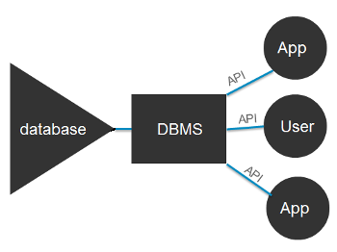

Fig. 1.0: Database Management System

**Database Management Systems**

A Database is a collection of records. Database management systems are designed as the means of managing all the records. Database Management is a software system that uses a standard method and running queries with some of them designed for the oversight and proper control of databases.

**SENIOR CITIZEN**

Old age refers to ages nearing or surpassing the life expectancy of human beings, and is thus the end of the human life cycle. In October 2016, scientists identified the maximum human lifespan at an average age of 115, with an absolute upper limit of 125 years. Terms and euphemisms for old people include, old people (worldwide usage), seniors (American usage), senior citizens (British and American usage), older adults (in the social sciences, the elderly, and elders (in many cultures—including the cultures of aboriginal people). (Zimmer, 2016)

Old people often have limited regenerative abilities and are more susceptible to disease, syndromes, and sickness than younger adults. The organic process of ageing is called senescence, the medical study of the aging process is called gerontology, and the study of diseases that afflict the elderly is called geriatrics. The elderly also face other social issues around retirement, loneliness, and ageism. The chronological age denoted as "old age" varies culturally and historically. Thus, old age is a "social construct" rather than a definite "biological stage".

**BENEFITS OF ICT TO SENIOR CITIZENS**

Originally, the purpose of old age pensions was to prevent elderly persons from being reduced to beggary, which is still common in some underdeveloped countries, but growing life expectancies and older populations have brought into question the model under which pension systems were designed. By 1990, the United States was spending 30 per cent of its budget on the elderly, compared with 2 per cent on education. The dominant perception of the American old age population changed from “needy” and “worthy” to “powerful” and “greedy,” old people getting more than their share of the nation's resources (Laura, 2003). However, in 2011, using a Supplemental Poverty Measure (SPM), the old age American poverty rate was measured as 15.9%. (James, 2008)

**THE EXISTING** **SYSTEM FOR SENIOR CITIZENS IN OSUN STATE**

At present in Osun State, the state government operated a separate database system which does not comprise both government and nongovernmental workers. The database system is operated by different ministry in the state. For example the database of retirees is controlled by the pension scheme of the state which has nothing to do with nongovernmental senior citizen. This has been a major drawback for the state in controlling and monitoring the affairs of overall senior citizen in the state as a result of lack of centralized database system for senior citizen.

**THE DESCRIPTION OF THE PROPOSED ICT ASSISTED DATABASE FOR SENIOR**

**CITIZEN OF OSUN STATE**

The developed system was designed to be made up of the Senior Citizen Registration, and Search Forms and are described as follows:-

**Senior Citizen Registration Page**

This is the environment where both Government and Non Government workers’ registration takes place. The environment consists of Personal details, Biometric Details (face) and Occupational Details as shown in Figure 3.3.

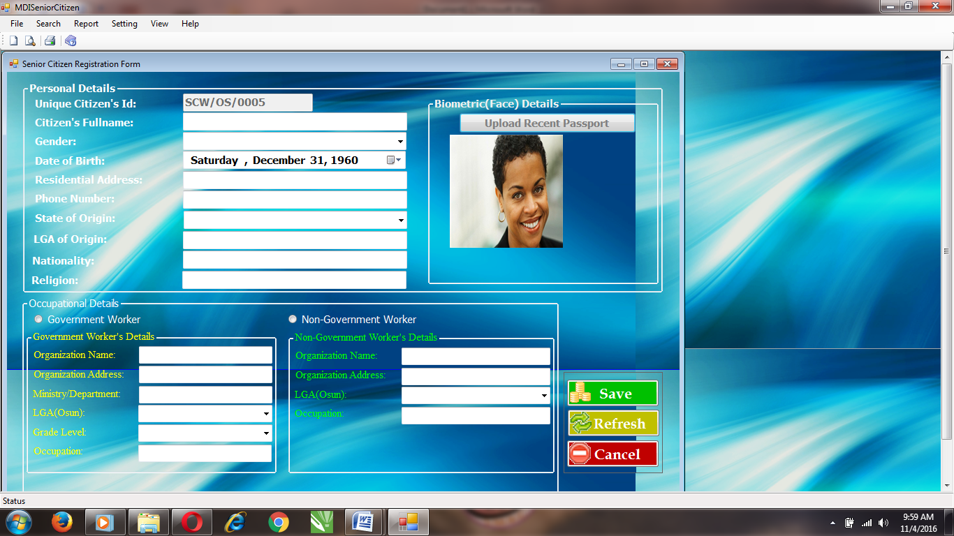

Figure 1.1 Senior Citizen Registration Page of the developed system

**The Search Page**

The Search Page is the environment where the user of the system can search the list of the registered Senior Citizen users in Osun State. The user can wither search with the citizen user ID or Biometric (face) to retrieve the user information as shown in Figure 1.2.

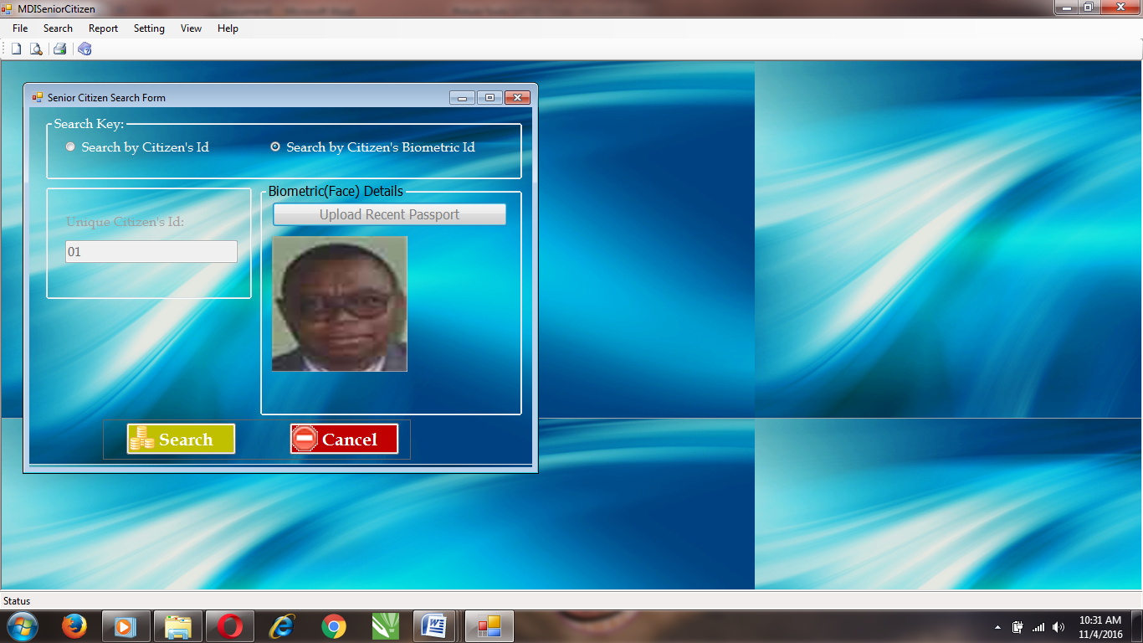

Figure 1.2 Search Page of the design view on developed system.

**CONCLUSION AND RECOMMENDATION**

In this paper work, An ICT Assisted Database for Senior Citizen of Osun State was designed and implemented using Microsoft Visual Basic .NET programming language and Microsoft Access was use as the database backend. The developed system was evaluated based on usability and speed of the system.

It is concluded from the result of the implementation, that the developed system is usable, easily accessible and it provide a secured database system for Senior Citizen in Osun State has been developed. It is recommended that:

1. The developed system should be used for keeping records and information of Senior Citizen in the Osun State, in order to gather all relevant information of the Old People in the State.
2. The developed system can also be design and place on network which all the senior citizen will be able to access without visited a particular zone.

**REFERENCES**

Barry, Patricia. (2016)"Medicare Eligibility Requirements - How to Qualify for Medicare –

AARP Every...". AARP.

Bachman, (1973), "PTCA in the elderly: The "young-old" versus the "old-old"". Journal of the

American Geriatrics Society. 40 (1): 19–22.

Chaffin A. J., Harlow S. D. (2005) Cognitive learning applied to older adult learners and

technology. Educational Gerontology. 2005;31(4):301–329.

Chapple, (2005) Use of the computer and the internet by well older adults. Activities,

Adaptation & Aging. 2013;37(1):63–68. doi: 10.1080/01924788.2012.729186.

Hawthorn D. (2000) Possible implications of aging for interface designers. Interacting with

Computers. 2000;12(5):507–528. doi: 10.1016/S0953-5438(99)00021-1.

Heying Jenny, Z., Xiaotian, F., &Baozhen, L. (2008). Placing Elderly Parents in Institutions in

Urban China: A Reinterpretation of Filial Piety. Research On Aging, 30(5), 543-571.

Hyderabad and Pat Thane, (2010), Old Age from Antiquity to Post-Modernity (Routledge)

Kumada, (2009) Aging, The Individual & Society (Cengage, 10th edition, 2014), 6-7.

Lalitha, (2004) History of Old Age: From Antiquity to the Renaissance, trans. Sarah Hanbury

Tenison (University of Chicago Press, 1989) Minois, 303.

Laura Katz Olson, (2003) The Not-so-golden Years: Caregiving, the Frail Elderly, and the Long-

term Care Establishment (Rowman and Littlefield, 2003), 4.

Margaret Rouse (2005) “Database Definition”

McConatha D. (2002) Aging online: toward a theory of e-quality. In: Morrell R. W., editor.

Older Adults, Health Information, and the World Wide Web. Mahwah, NJ, USA: Lawrence Erlbaum Associates; 2002. pp. 21–41.

Melenhorst A.-S., Rogers W. A., Bouwhuis D. G. (2006) Older adults' motivated choice for

technological innovation: evidence for benefit-driven selectivity. Psychology and Aging.

2006;21(1):190–195. doi: 10.1037/0882-7974.21.1.190. [PubMed]

Murray A., Gregor P. (2011) Computer use has no demonstrated impact on the well-being of

older adults. International Journal of Human Computer Studies. 2006;64(8):744–753. doi:

10.1016/j.ijhcs.2006.03.001.

Patsoule E., Koutsabasis P. (2014) Redesigning websites for older adults: a case study.

Behaviour & Information Technology. 2014;33(6):561–573. doi: 10 .1080/0144929x.2013.810777.

James S., Guijarro J.-M., Blat J. (2012) Selective attention in web forms: an exploratory case

study with older people. Behaviour and Information Technology. 2012;31(2):171–184. doi: 10.1080/01449291003767920.

Slegers K., van Boxtel M. P. J., Jolles J. (2012) Computer use in older adults: determinants and

the relationship with cognitive change over a 6 year episode. Computers in Human

Behavior. 2012;28(1):1–10. doi: 10.1016/j.chb.2011.08.003.

Tatnall A. (2014) ICT, education and older people in Australia: a socio-technical analysis.

Education and Information Technologies. 2014;19(3):549–564. doi: 10.1007/s10639-

013-9300-x.

Wagner N., Hassanein K., Head M.(2010) Computer use by older adults: a multi-disciplinary

review. Computers in Human Behavior. 2010;26(5):870–882. doi: 10.1016/j.chb.2010.03.029.

Wandke H., Sengpiel M., Sönksen M. (2012) Myths about older people's use of information and

communication technology. Gerontology. 2012;58(6):564–570. doi: 10.1159/000339104.

Zimmer, Carl (2016). "What's the Longest Humans Can Live? 115 Years, New Study

Says". New York Times. Retrieved October 6, 2016.